Magnetic lab
Half width
-Depth estimation is one of the main objectives of magnetic interpretation.
Simple rules give depths to the tops of source bodies that are usually correct to within about 30%, which is adequate for preliminary assessment of ﬁeld results.
Depth = ½ width between the flanks of curves of an amplitude of ½ maximum amplitude
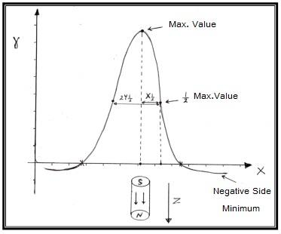
= X1/2 max

Problem1:
An magnetic survey was conducted in a regions using a (Flux – Gate Magnetometer) instrument, the vertical component of the magnetic field strength was measured , also a contour map of the magnetic anomaly were drawn.
- Plot a magnetic anomaly curve along the section A-B
- Find the depth of the metallic body that causes this anomaly
- Show the location and the extend object on the map.

